XLC- CAPTUR

TEAM DESCRIPTION PAPER

Team Introduction

Since our founding in 2009, XLC Captur has been dedicated to advancing the field of robotics through innovation and teamwork. We are proud to introduce our talented team members, each bringing unique skills and expertise to our collective effort.
Ondrej Peter: Our electrical designer, Ondrej, is the backbone of our team's electronic systems. His meticulous designs ensure our robots operate with precision and reliability.
Martin Šuriak: Serving as our 3D modeler, mechanical designer, and all-around helper, Martin is the creative force behind our mechanical components. His designs are both functional and innovative, pushing the limits of what our robots can achieve.
Jakub Bohunický: Our programming expert, Jakub, breathes life into our robots through his exceptional coding skills. His programs are the brains behind our robotic operations, ensuring they perform flawlessly under competition conditions.
Together, we form a cohesive unit driven by a shared passion for robotics and a commitment to excellence. We are excited to compete and demonstrate the capabilities of our latest robotic creations.
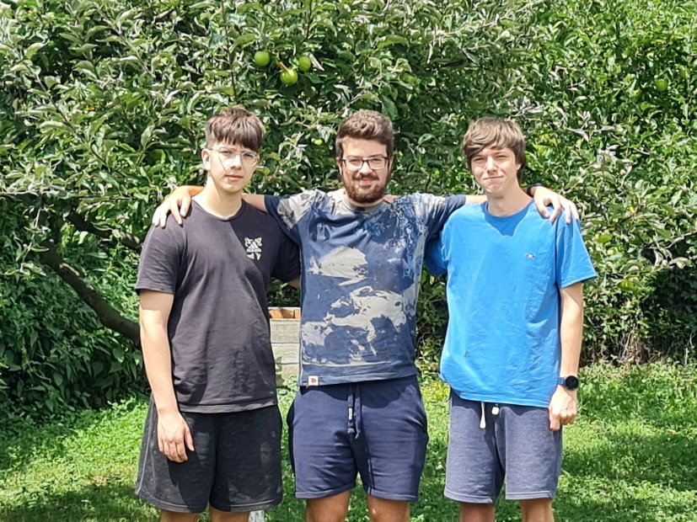
Figure 1: Our team photo

Desing overview
We began designing the first generation of our robot in late 2022 to compete in our home country's 2023 RoboCup Junior competition. Since then, we have developed many new skills, tackled design challenges, and learned from our failures.
Last year's competition turned out great for us, as we achieved 3rd place despite our robot's flawed designs, numerous malfunctions, and our initial struggles with coding.
This year, we have worked extremely hard and developed a new design for our top PCBs. We switched microcontrollers, added new sensors for IR ball detection and a camera, upgraded the gyro sensor, and integrated a kicker and dribbler.

Mechanical design:

First, we began designing our robot as a 3D model in Fusion 360. This proved to be an excellent tool because it allowed us to create the robot according to the specified dimensions outlined in the competition rules. We decided that the main structure of our robot would be made of PCBs, and 3D modeling enabled us to seamlessly convert the robot's shape in Fusion 360 directly into PCB designs in EAGLE.
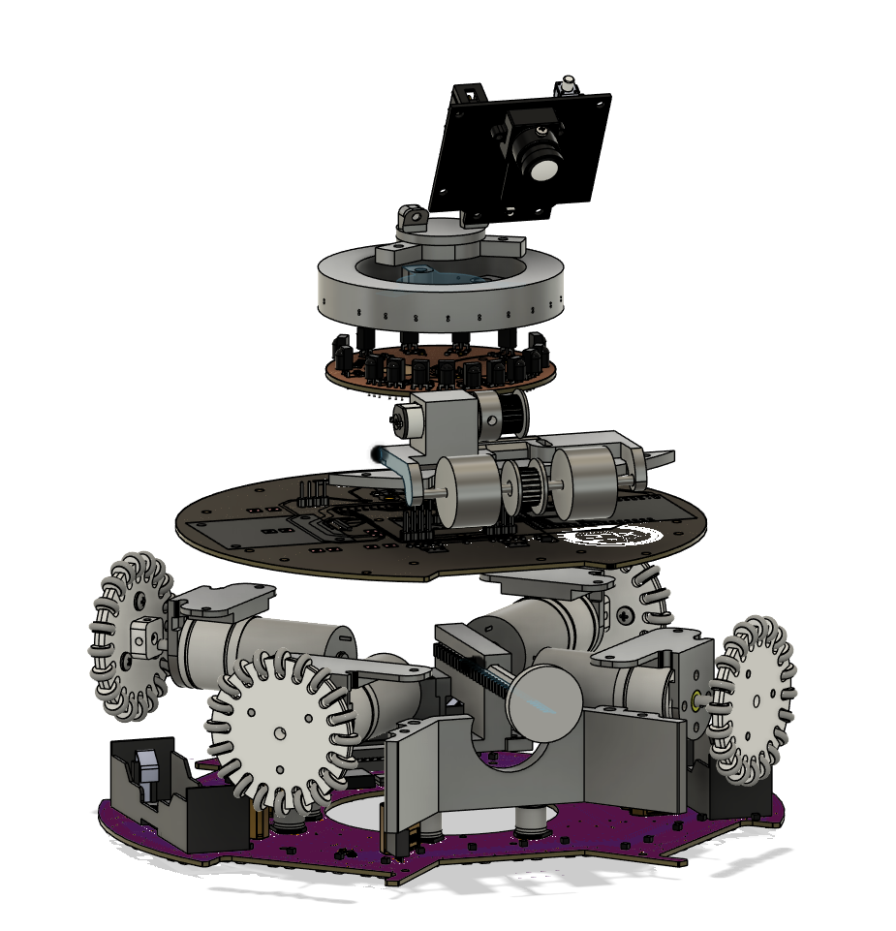
Figure 2: 3D model for current version of our robot

Kicker:
Our testing phase started with solenoids we had on hand, along with a DC motor that we adapted to move linearly using a small amount of 3D printing.
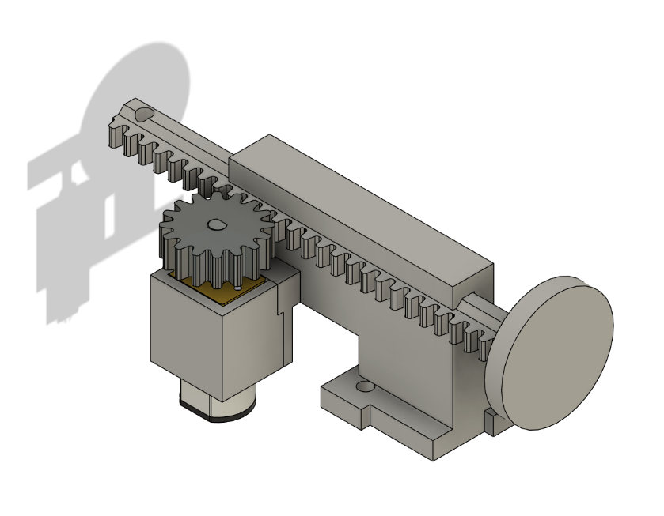
Figure 3: 3D model of our kicker
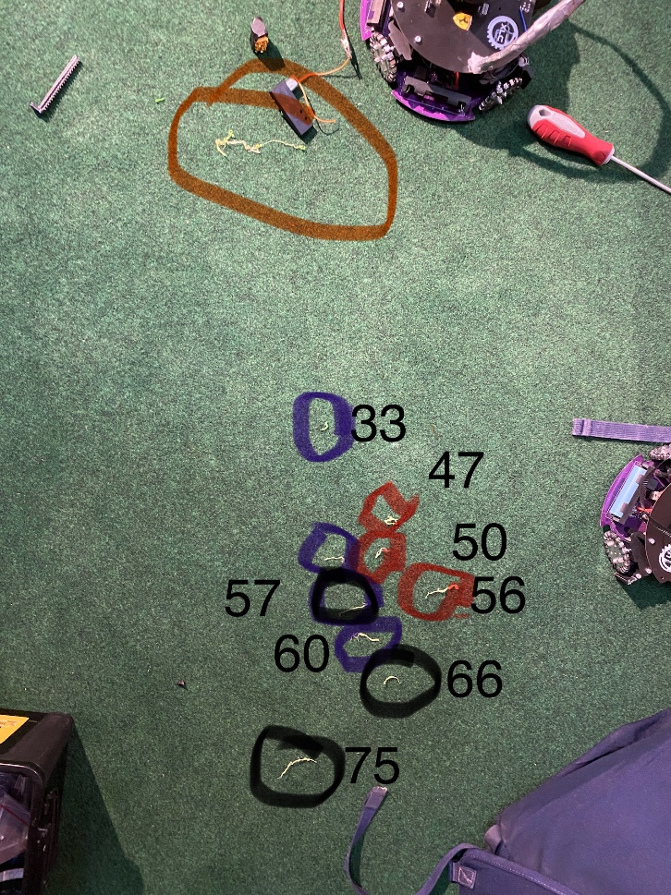
Figure 4: Our testing: red and purple are solenoids and black is our linear DC motor

Dribbler:
The dribbler consists of a DC motor connected by a GT2 belt to a rubber roller from a printer paper feeder, chosen for its softness and good adhesion properties. This rubber roller serves as the contact point for the ball, causing it to spin.
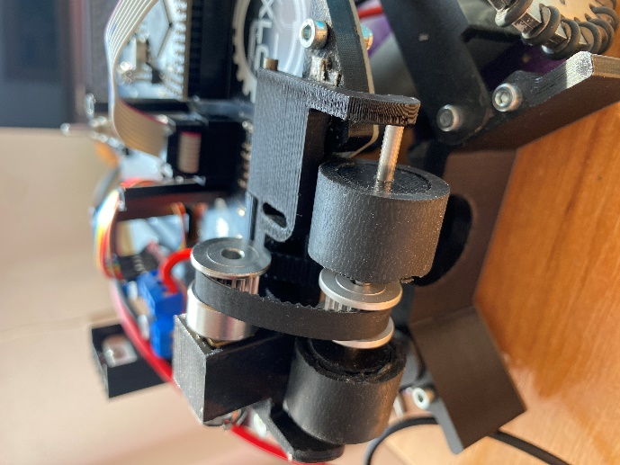
Figure 5: Dribbler with rubber rollers
To detect whether the ball is in the dribbler, we use a mechanical contact consisting of two parts of desoldering wire. When the dribbler makes contact with the ball, it lifts up and separates the contacts.
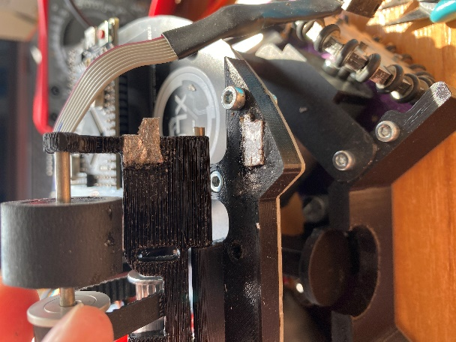
Figure 6: Ball detection switch

Electrical design:
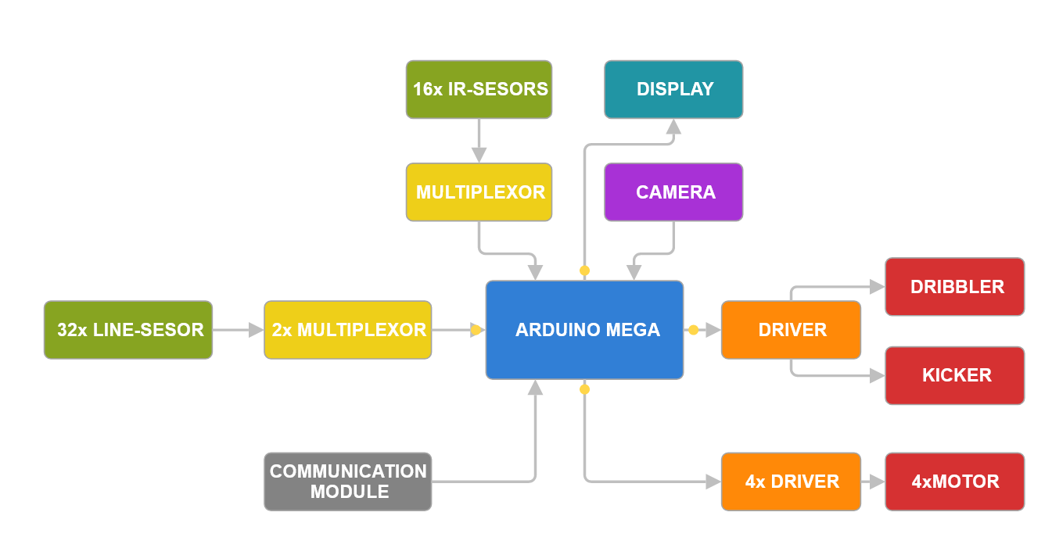
Figure 7: Logic block diagram
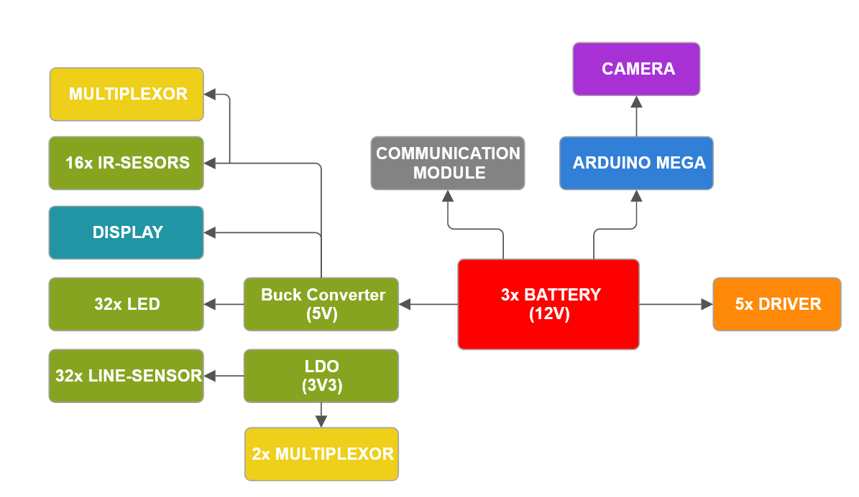
Figure 8: Power block diagram

Line Sensors: To detect the field borders, we use phototransistors that sense reflected light from the field. When our robot moves over a white border line, the sensors detect a change in voltage.
Use of Multiplexers: Given the limited number of analog inputs on the Arduino Mega, we use multiplexers for the line and IR sensors to expand our input capacity.
Camera: We utilize the Pixy Cam V2, which is connected to the Arduino via ISCP pins.
Motor Drivers:
Battery:
IR sensors:

Software design:

